# Supporting Information

## **Implementation**

Cr, Cs and DI are implemented in the R package WildlifeDI (Long and Nelson 2013). The approach of Schlaegel et al. (2019) was applied here using two R packages: The raster() function within the R package raster (Hijmans et al. 2022) was used to create a spatial map containing the occurrence distribution estimates which were calculated with the function rolling_od() within the R package amt (Signer et al. 2019). For the SSF-DIST approach, the raster() function was also used to create the dynamic spatial map containing distances of one individual to all the cells in the map calculated with the distanceFromPoints(). The function extract_covariates_var_time() in amt was then used to include both occurrence estimates and distances as covariates in the SSF analysis. The model used to simulate the data as well as the analyses of the obtained results are available on GitHub [link to repository upon acceptance].

## **Supplementary figures**

*Figure S1: Results from applying the methods Cs, Cr, DI, and the SSF-DIST approach on simulations with 1 prey and a perceptual range of the predator of 4 at two different sampling resolutions (2 %, and 100 %). The simulation was run for 10´000-time steps.*

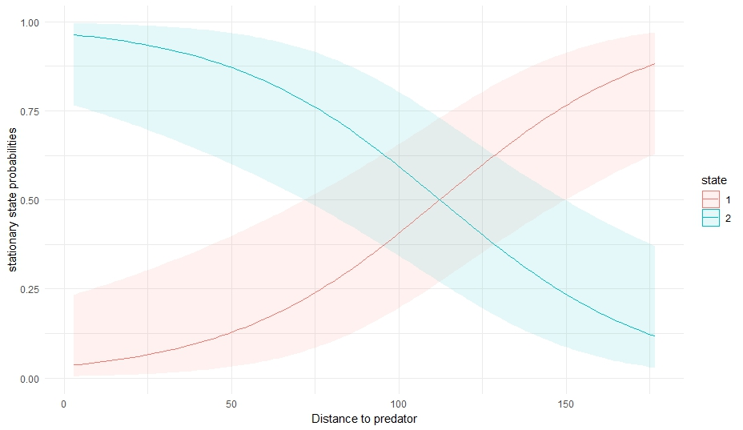

*Figure S2: Results from applying HMMs on the simulated movement of a prey being hunted by a predator. The prey has a state 1 (correlated random walk) when not interacting and a state 2 (persistent run) when interacting with the predator. A 95% confidence interval is drawn around the calculated state probability.*

## **HMMs as an alternative approach**

An approach to identify different behavioural states, Hidden Markov models (HMM), can be used as they allow to identify major movement states in telemetry data based on the changes in the animal’s step length and turning angle (Langrock et al. 2012; Patterson et al. 2009). We briefly tested whether HMMs can be used to identify a switch of movement state resulting from the distance between individuals.

In this simulation, the predator and prey have a state in which they do a random walk with small steps and a second state in which they have a highly persistent walk with large steps. They are in their second state when an interaction is occurring between the predator and prey (being under a specific distance to each other). The movement data of the prey is used here in the HMM. The distance between predator and prey is then used as a covariate to predict the switch from one state to the other. The figure clearly shows, that when the distance between predator and prey is large, the probability of being in state 1 is high and being in state 2 is low. However, when the distance between predator and prey reduces, the probability of being in state 1 reduces and state 2 increases. This highly suggests that when they get in close proximity to each other, the prey switches from state 1 (random walk = resting) to state 2 (persistent walk = fleeing).